Strategic Plan
Template
[Author Name]
[Publish Date]
[Company name]
[Company address]

Abstract
A brief abstract describing the salient points of the strategy, no more than 3 paragraphs
Write your abstract here
PLEASE NOTE: All instructions in the following document are provided in grey italic font like this. Any instruction text should be deleted. The body text in this document use style called ‘Normal’ and can be modified to suit the needs of your strategic plan. Any text in ‘Normal’ font is an example.
This is Version 7 of the Strategic Plan template, last updated in July 2018

Table of Contents

Abstract 1
Vision 3
Mission 3
Core Values 3
Strategic Priorities 4
Strategy Map 7
Business Objectives 8
Strategic Initiatives 9
Financial Summary 10
Appendix - Integrated Strategy Map 11

Vision
Add the company vision – remember this is a statement about the future, only a single line. It should be inspirational and unique, for example:
Transforming society through the provision of ultra-high speed mobile information services

Mission
Add the company Mission – this is a statement about what you do today, what you produce and/or what services you provide. It is factual, anyone from your company should read it and say ‘Yes, that is exactly what we do today’, for example:

The number one provider of ultra-high speed mobile networks. We provide a variety of valuable content, including news, sport, entertainment and educational services, to the United Kingdom.

Core Values
Core values provide the foundation upon which a business is built. These are the values any employee will sign up to when joining a company. They are the values that anyone looking at the company would automatically relate to. They have to be honest. A core value that is not in keeping with a company image has no value at all (other than a negative value). It is important to only have a few core values small, five or six is considered optimum. A label and description is required. The label is usually used externally, the description internally. For example:
Core Value | Description
Honesty | We are honest to a fault, we would rather disappoint a customer than lie.
Integrity | Our word is our bond, we will always deliver on a promise.
Friendly | We are approachable, we do not hard sell, and we wait to be asked.
Etc.

Strategic Priorities
In any business small or large, there will be a need to break down a strategy into two or three overarching workable areas. These ‘Strategic Priorities’ provide a focus to more effectively create a set of business objectives. The strategic priorities can be found by looking at challenges and enablers in the first instance and then confirming the priority through something like a Strategy Canvas.

Challenges and Enablers
If you are familiar with SWOT (Strengths, Weaknesses, Opportunities, and Threats), looking at challenges and enablers is similar to that process. The key is to be aware of all areas of impact, both good and bad, and derive from that your strategic priorities. Typically, this exercise will generate dozens of challengers and enablers, these are usually summarised in a table. This section has a short narrative followed by the summary table, for example:
The following table is a summary of a much more extensive set of challenges and enablers that were identified using the SWOT process. Through the information gained we can see that there is a need to quickly build on our current successes to develop our brand. There is also a need to focus on content supply and acquisition and to enhance our technical abilities to better utilise content and provide up-to-date user interfaces.
Challenges | Enablers
(Strengths) | (Weaknesses)
- Number 1 provider of ultra-high speed mobile network services  - Successfully launched a new handset and three new major content initiatives  - We own a ultra-high speed network | - Older company, seen as a bit stuck in the past especially by young  - Content provision, especially entertainment, it is good but not the best  - Leadership team has recently changed, no track record
(Opportunities) | (Threats)
- Working closely with major content providers to secure exclusive distribution  - Building on a successful launch, re-invigorate our brand  - Capitalise on our ownership of a ultra-high speed network | - Increase competition, especially from multi-play (TV, Broadband) entrants  - Changes in government regulations esp. free 0800 numbers  - Competition stepping up marketing and advertising rapidly

Strategy Canvas
A Strategy Canvas provides a means to quickly identify strategic priorities. Building a strategy canvas can be undertaken ‘off-the-top-of-head’ or thorough extensive research or a combination of both. The results provide a visual representation of strategic priority or focus. This section would normally start with a short narrative followed by an image of the strategy canvas, for example:
The following Strategy Canvas has been developed by using a combination of in-house expertise and additional research where required. The canvas indicates, as expected, that in relative terms our content supply is not as strong as it should be and that our customer service is lacking. Our brand is relatively good, but the external research shows we do not appeal to a younger audience.
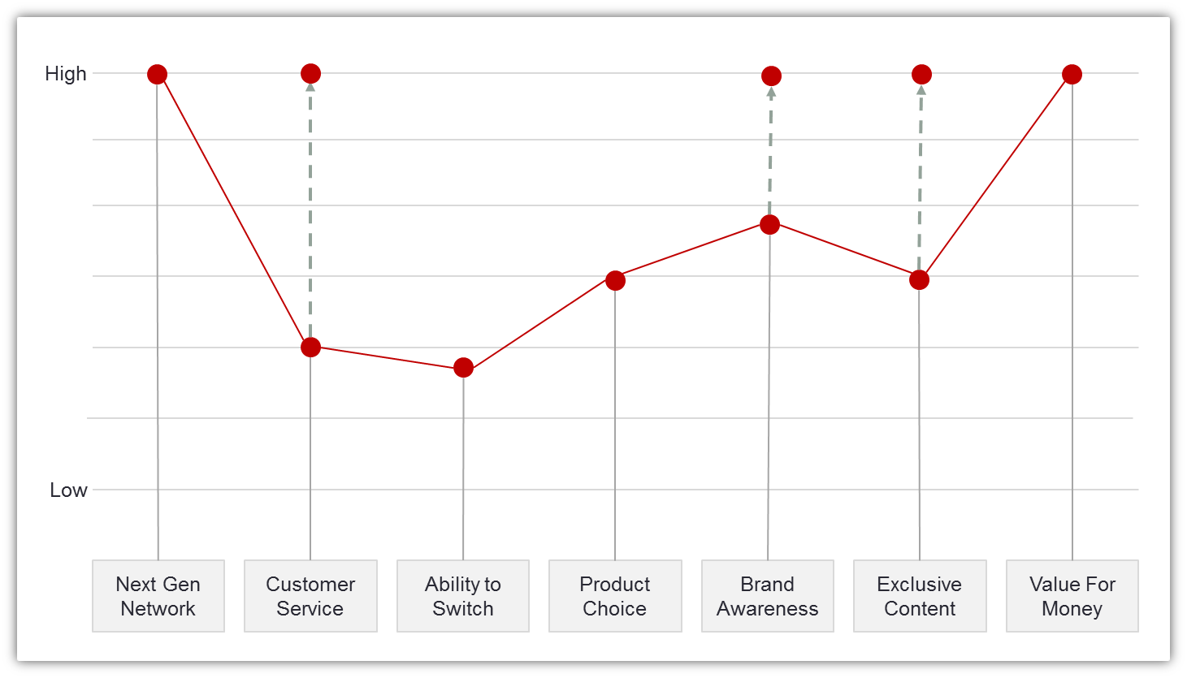

Customer Value Proposition
A good vison and mission statement makes it possible to describe exactly, and in compelling terms, what is being offered to a customer. The only exception is if a break-out strategy is being devised to take the organisation into a completely new direction. The Customer Value Proposition starts with a statement that clearly describes the product or service firstly in terms of its functionality and secondly in terms of the relevance, benefit and difference it makes to the customer. Do not fall into the trap of using internal jargon.
One of the most famous templates still widely used today is from Geoff Moore’s seminal book ‘Crossing the Chasm”. It goes like this:
For – a short description of the customer
Who – a short description of the problem
Our – a short description of the solution
So that – a short description of the benefit derived.
The value proposition should be no longer than 30 words, for example:

For people who need fast communications where ever they are our extensive networks provide ultra-high speed connections so that they can send and receive information in any format including documents, images and video.

Having gone through the three activities above, that is SWOT, Strategy Canvas and Customer Value Proposition, and documented the results of each should be enough information to define three strategic priorities. This final Strategic Priority exercise is usually undertaken as a group workshop with the key players from areas that have most influence on strategic implementation.

Based on the SWOT Analysis, Strategy Canvas, and Customer Value Proposition, we have set three Strategic Priorities:
 | Strategic Priorities
Content Partnerships | Customer Service | Brand Awareness
We have a strong supply chain for content and information services, and have put in place secure exclusive arrangements | Our combined ultra-high speed network and content delivery allows us to provide exemplary customer service that astonishes our customers | We have capitalised on our recent successes and reinvigorated our brand allowing us to target a wider and younger audience

Note: the above strategic priorities have descriptions that are in a ‘results-oriented’ language. That is, they describe an outcome as if it has happened.

Strategy Map
A Strategy Map is a visual representation of a set of business objectives grouped using a Balanced Scorecard format. That is, business objectives related to four areas or ‘perspectives’ called Financial, Customer, Internal Processes, and Organisational Capacity. Most importantly, the strategy map also links the cause and effect relationships for the business objectives. For example:
The major thrust of our strategy is to improve the way we procure and deliver information and content over our existing ultra-high speed network while continually improving the end-user experience.
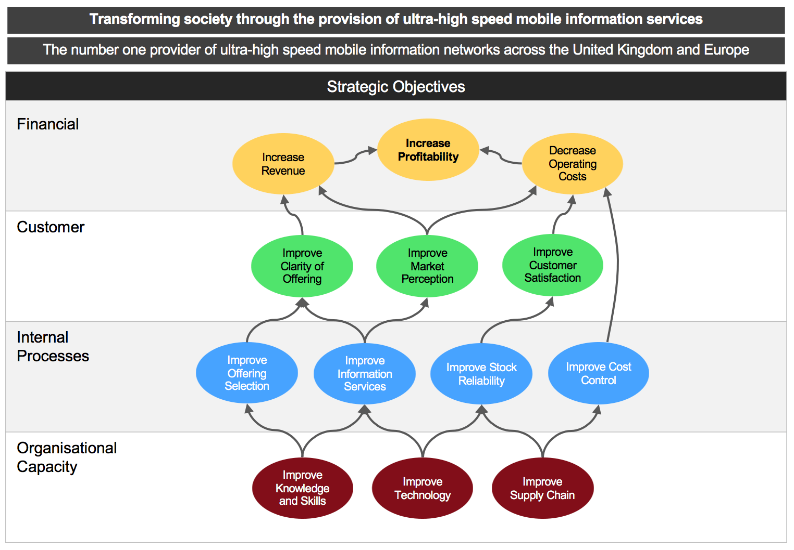
Further narrative about the overall strategy should go here
There will almost certainly be a need to provide some further narrative at this point, one or two paragraphs will do. The author must not forget that many of the readers of this document will not have gone through the strategic planning process and so need some background. The business objectives form the key part of the strategy and so it is well worth the effort to provide a concise overview.
This document concentrates on the top level or corporate strategy. In medium to large and enterprise sized organisations, the above strategy map would be ‘cascaded’ to divisions and/or departments. The divisions and/or departments would then go through the same strategic process and create a strategy that contributes to the corporate strategy.
The result would be several documents, one for each division and/or department in the same format as this one.

Business Objectives
Each business objective must have an intended result. The business objectives in the strategy map are useful for presentational purposes, but to ensure the desired outcome is reached a description is required. The language used to describe the intended result should be ‘outcome based’, it should describe exactly, and in plain language what is meant by the label. In addition, each business objective must be measurable, have a target and an owner. For example:
Business Objective: Increase Profit
Intended Result: Increased total profit as a sum of all divisional profit
Measures | Target | Owner
Net Profit in GBP (monthly) | £xxxM/month | Bill Peters
Net Profit % (monthly) | 7% | Bill Peters

Business Objective: Improve Content Supply
Intended Result: Our content supply chain is robust, it is varied and includes exclusive deals
Measures | Target | Owner
Number of content providers | 30 | Paul Smith
Number of prime content providers | 10 | Paul Smith
Number of exclusive deals | 5 | Paul Smith

Business Objective: Improve our Technology
Intended Result: Improved technology used to deliver content and information services
Measures | Target | Owner
Number of customer service calls related to technology | <50/month | John Jones
Number of unsolicited electronic compliments | >10/month | Harry Johnson
Customer satisfaction survey (quarterly) | >90% | Anna Franks

Business Objective: etc.
Intended Result:
Measures | Target | Owner

Strategic Initiatives
Strategic Initiatives are the ‘engine’ that drives change. Without strategic initiatives nothing will change, you will put in place objectives and happily measure them, but will have nothing tangible in place to drive the strategic change you are looking for. There does not need to be a one-one match between business objectives and strategic initiatives, in fact one good strategic initiative might drive improvements in several areas. The section should start with a short narrative and then describe the initiatives, for example:
The following initiatives focus on the core activities required to implement our strategy, they are in priority order and represent the corporate view. Where indicated there will be separate departmental tasks that feed into the corporate initiatives.
Strategic Initiative: 1.0 - Approach the Football Association to explore content partnerships
Business Objective(s) Impacted: Improve Content Supply, Improve Information services
Description: Work with the Football Association to determine which of next year’s fixtures are available for mobile broadcast next year. Build the plan to support and implement this
Major Sub-Initiatives | Owner | Start Date | End Date
1.1 – Initiate talks | Steve Goodham | Sept 2018 | Nov 2018
1.2 – Develop plan | Steve Goodham | Nov 2018 | Feb 2019
1.3 – Build mobile environment | Paul Smith | Jan 2018 | June 2019
1.4 – Roll out service | Paul Smith | July 2018 | Onwards

Strategic Initiative: 5.0 – Redesign the Website
Business Objectives(s) Impacted: Improve End User Experience, Improve Technology
Description: Completely overhaul the website utilising the latest technologies, bring in a new design company to work on the user interface, roll out by Jan 2016 at the latest
Major Sub-Initiatives | Owner | Start Date | End Date
5.1 – Create a design brief | John Jones | May 2018 | July 2018
5.2 – Run tendering process | John Jones | Aug 2018 | Oct 2018
5.3 – Build new website and test | John Jones | Oct 2018 | Dec 2018
5.4 – Roll out website | Paul Smith | Jan 2018 | Mar 2019

Strategic Initiative: 3.0 - Etc.
Description:
Major Sub-Initiatives | Owner | Start Date | End Date

Financial Summary
Please note: This is not a business plan, it is a strategic plan. It is unlikely you will be able to quantify exactly what the financial impact will be, however, you should be able to quantify the approximate costs of the initiatives and state a ‘relative’ impact to the business. If you can be exact, then great, but under normal circumstances fully costed business plans are a separate exercise. This section would start with a short narrative and be followed with the costs and impacts. For example:
At this stage the exact costs and benefits of the strategic plan have not be calculated, this will be done at a later date. However, the following provides a set of estimates based on the information available. These initiatives have been prioritised and assigned, business cases are being produced and will be available from July 2016 onwards.
Initiative | Completion | Cost | Benefit
1.0 – Approach Football Association | July 2018 | £3.5 million | £10s millions
2.0 – Revalidate deals with BBC Sports | July 2018 | <£300k | £10s Millions
3.0 – Create the Omega Games platform | Sept 2019 | <£1.5 million | >£5 million
4.0 – Improve the offering selection process | Oct 2019 | <£100k | Savings?
5.0 – Redesign the website | Jan 2019 | <£250k | £1-7 million
11.0
12.0
13.0
Etc.

Appendix - Integrated Strategy Map
An integrated strategy map should be included for completeness. There should be a pointer to the actual presentation as the map in this format is too small to be useful. However, it does indicate that this iteration of the strategic planning process has been completed. The section should start with a short narrative explaining what the map is and why it has been attached, for example:
The following is Integrated Strategy Map has been included for reference only. The map can be found in the shared area at location www.nameofcompany.com/strategy. The map shows that a full set of business objectives, measures, targets and initiatives have been identified at the company level. Many of these will be cascaded as-is, some will refined to suit the needs of our departments. The Integrated Strategy map will appear on the public intranet and will be posted on notice boards in selected areas.

